NUS Lecture Notes

# Signal Processing Methods for Sound Recognition

Dr. E. Benetos

Conferences – ISMIR 2005, ICA 2007, MPEG 2009, CMMR 2012, WAC 2017, Audio Mostly 2017, SysMus 2017

Software – Sonic Visualiser (+Vamp plugins), SoundBite, Tony

**Machine Listening for Sound Scenes**

* Sound scene recognition
* Sound event detection
* Source separation
* Noise monitoring/reduction

**Sound Event Detection ( SED )**

Main goal: identify labels and start/end times for sound events

**Matrix Factorization**

Spectrogram ( frequency-time representation ) – treat as a matrix and factorize into two matrices

NMF ( Nonnegative Matrix Factorization)

VFxT = WFxK x HKxT

K refers to the rank of the matrices. Can be thought of as the number of con-current sound events you want to detect.

Nonnegative matrices – W (dictionary of templates containing signatures of events) , H ( activation matrix)

PLCA – Probabilistic Latent Component Analysis

$$V_{ω, t}=P\left(ω,t\right)=P\left(t\right) Σ P\left(w | z\right)P\left(z | t\right)$$

* Decompose a bivariate distribution over frequency and time
* Probabilities of frequencies over particular component ( W )
* Probabilities of component over time ( H )

**Recognizing multiple overlapping sounds**

Mel and ERB spectrograms – they are essentially different filterbanks

Mel- frequency cepstrum : representation of the short term power spectrum of a sound.

$$V_{ω, t}=P\left(ω,t\right)=P\left(t\right) Σ P\left(ω | q,c,s\right)P\left(s | t\right)P\left(c | s, t\right)P\left(q | s,t\right)$$

* P(t) : spectrogram energy ( known quantity )
* First term : spectral template for event class s , exemplar c, and sound state q ( fixed, pre-extracted )
* Second term : event activation over time
* Third term : exemplar contribution for each event class, over time
* Fourth term : sound state contribution for each event class, over time. Controlled by an event HMM

Application source code : <https://code.soundsoftware.ac.uk./projects/sound-event-detection-plca>

Tracking sequences over time using Hidden Markov Models ( discrete ) or a State Space Model ( SSM )

**Linear Dynamical System** is a state space model where all the conditional probability distributions are linear-Gaussian.

* Given some output you can infer information about some hidden variables/features.
* The hidden variables are linked by a transition matrix

Approach : Use LDS to track multiple concurrent sound events

Motivation : Assume the posteriogram is the observation in an LDS, with the latent states corresponding to the ‘clean’ posteriogram. Essentially clean up the model which was unsatisfying and noisy.

**Future perspectives**

* Use of context to better inform models
* Sound event taxonomy
* Language/ library modeling

# Automatic Music Transcription by Dr. Emmanouil Benetos

Dr. E. Benetos

**Introduction**

Mid-level and parametric representation:

* Pitch onset, offset, stream, loudness
* Audio time(s)

Notation:

* Note name, key, rhythm, instrument
* Uses score time (beat)

Prescriptive notation – an interpretation of the performance

Descriptive notation – provides the specifics of the performance

**Subtasks**

* Pitch detection
* Onset/offset detection
* Instrument identification
* Rhythm parsing
* Identification of dynamics/expression
* Typesetting

**Challenges**

* Music sources are not independent. The events are strongly dependent
* Inferring musical attributes from a mixture is an extremely underdetermined problem
* Data annotation is time consuming, leading research to be constrained towards specific tasks. Eg. Pianos with sensors in the keys (disk klavier)
* State of the art methods really struggle with symphonic pieces.
* The large variety of music

**Concurrent sound sources**

Concurrent sound sources interfere with each other.

* C4 (46.7%), E4 (33.64%), G4(60%)

The fundamental frequency identifies the notes but there are also frequencies present at integer multiples of the fundamental frequency.

**Consonant intervals and the problems they pose**

Octave - A2 = 110 Hz, A3 = 220 Hz

Perfect Fifth – A2 = 110Hz, E3 = 165Hz

Overtone series …

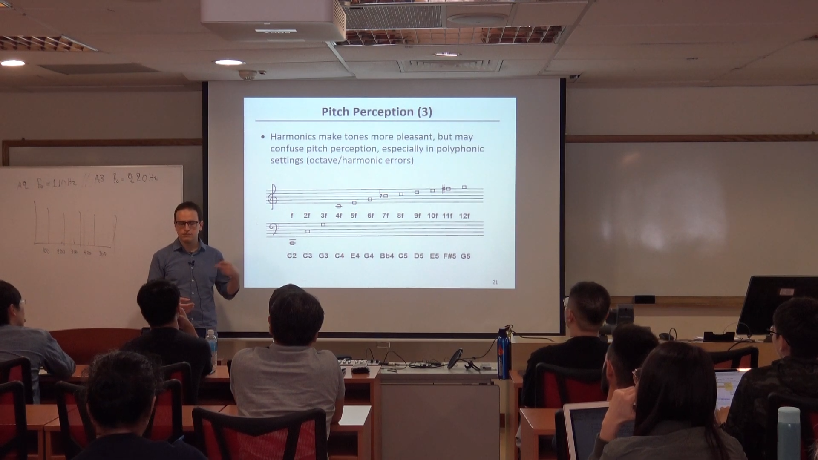

Source: E. Benetos, ‘Automatic Music Transcription’, Tutorial at the Department of Computer Science, National University of Singapore, available: <http://c4dm.eecs.qmul.ac.uk/nus-amt-tutorial/> [Accessed 19/8/2019]

And so on ……

How do we determine what note the energy is coming from?

**Pitch Perception**

* A sound has a certain pitch if it can be reliably matched to a sine tone of a given frequency at 40dB SPL.
* **People hear pitch on a logarithmic scale !**
* Pitch is salient in the range from 30Hz-5kHz
* The fundamental frequency does not need to be present for a pitch to be perceived
* For a sound with harmonic partials to be heard as a tone, its spectrum must include at least 3 successive harmonics of a common frequency

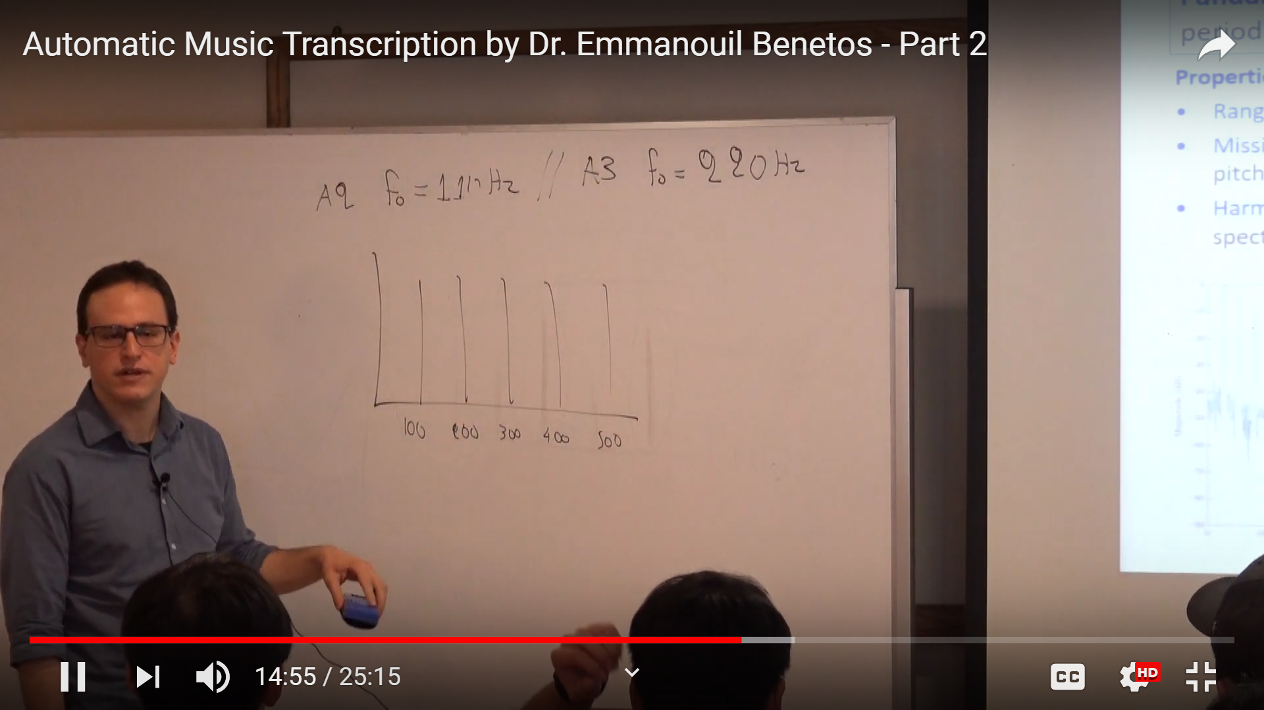

Source: E. Benetos, ‘Automatic Music Transcription’, Tutorial at the Department of Computer Science, National University of Singapore, available: <http://c4dm.eecs.qmul.ac.uk/nus-amt-tutorial/> [Accessed 19/8/2019]

Interestingly the lower notes on the piano are missing the lower harmonics!

Some instruments are quasi-harmonic ( i.e. The partials are shifted slightly )

Pitch perception theories inform the creation of AMT systems: pattern matching and autocorrelation models. Slide 22 of the presentation provides some references to some pitch perception models.

**Multi-dimensional aspects of pitches**

* Octave similarity – helix representation
* Circle of fifths - pitch distance

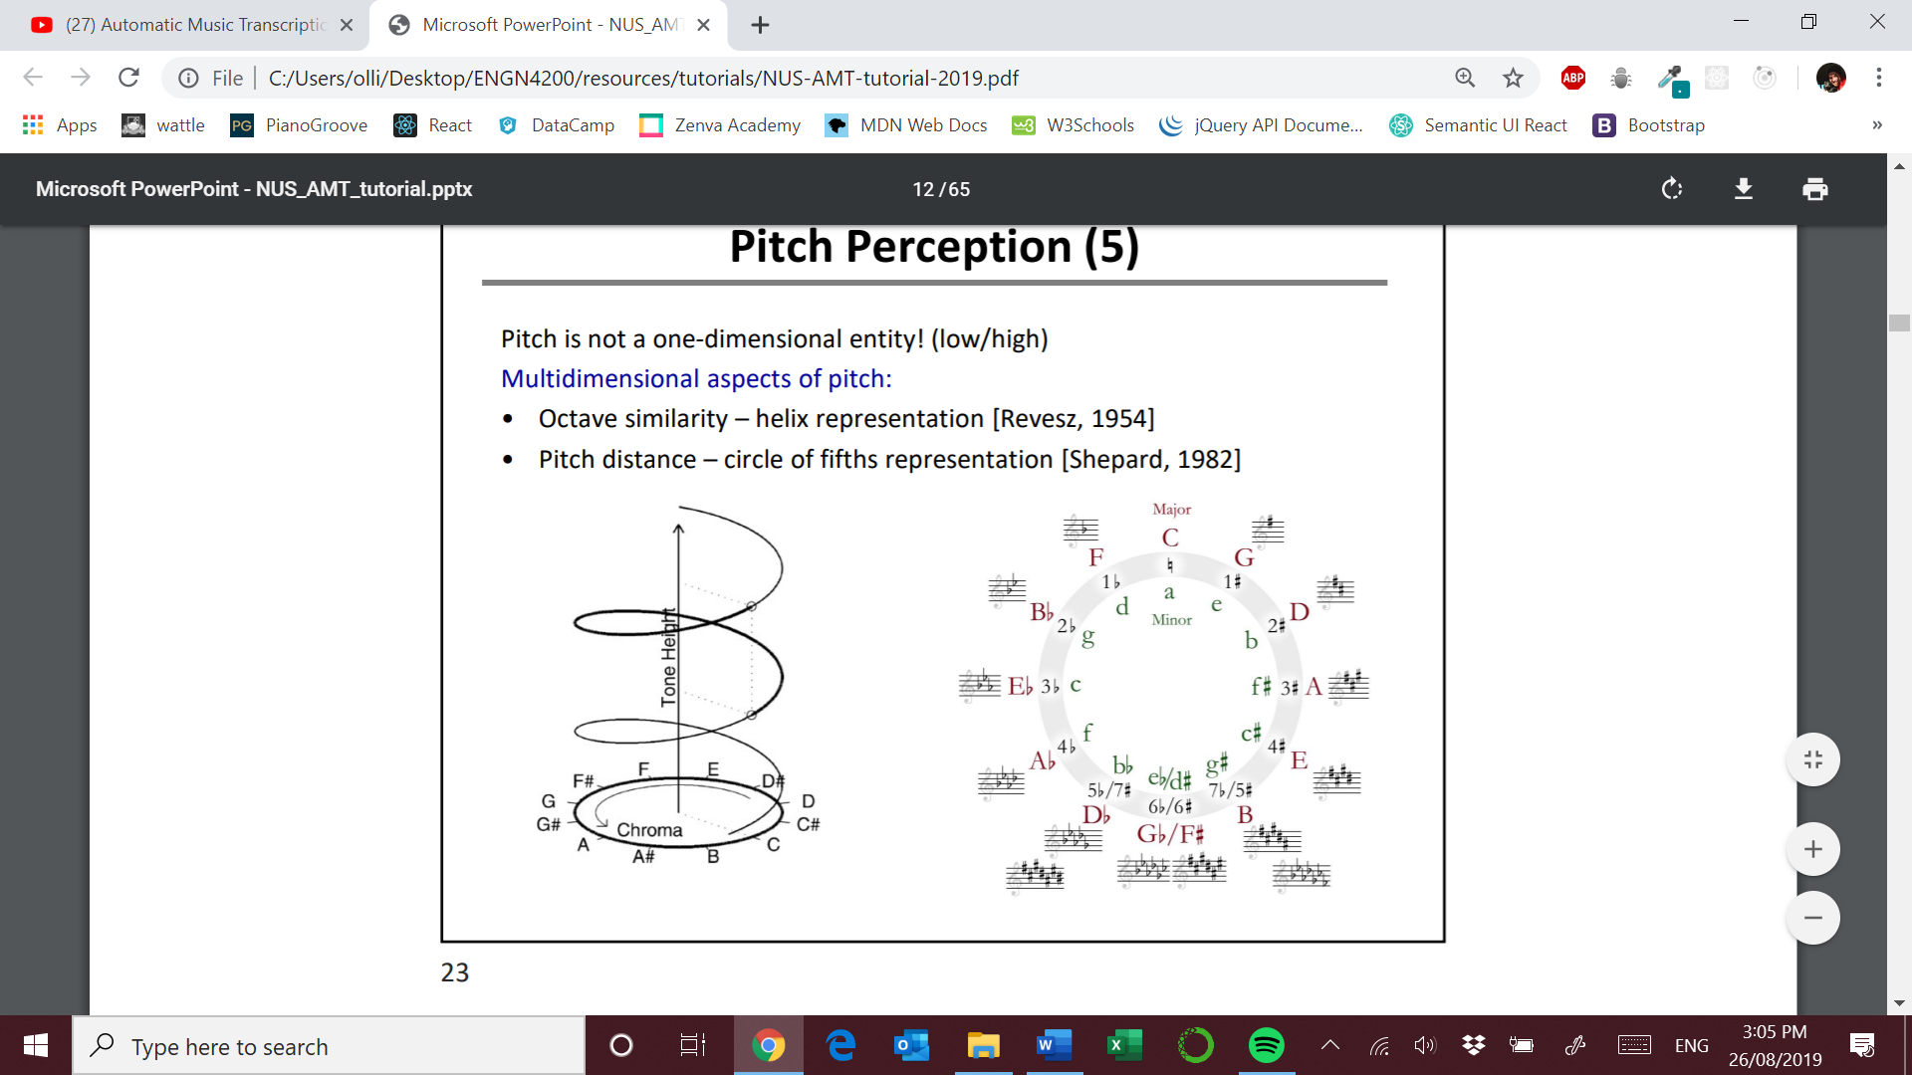

Source: E. Benetos, ‘Automatic Music Transcription’, Tutorial at the Department of Computer Science, National University of Singapore, available: <http://c4dm.eecs.qmul.ac.uk/nus-amt-tutorial/> [Accessed 19/8/2019]

**Human Transcription**

Implicitly humans are very good at:

* Style detection
* Instrument identification
* Beat tracking

Trained musicians should be able to transcribe two measures of a quartet after 3 or 4 playbacks.

**State-of-the-art Outline**

1. Frame level
   1. Estimate pitches in each frame
   2. Many methods
2. Note level
   1. Estimate pitch, onset and offset of notes
   2. Fewer methods
3. Stream level
   1. Stream pitches by source
   2. Very few methods

**Frame level**

Representation

* Time domain: raw waveform, auditory, filterbank
* Frequency domain: STFT, CQT, ERB filterbank, specmurt, spectral peaks

Core algorithms

* Rule based
* Signal processing
* Maximum likelihood
* Bayesian
* STFT decomposition
* Sparse coding
* Classification based

Iterative vs joint estimation???

**Time domain methods**

**ACF**

Harmonic sounds are periodic so we can use Autocorrelation functions (ACF) to find the signal period.

Problems: tends to have subharmonic errors ( mixing up octaves ), periodicity is unclear when multiple harmonic sounds are mixed

**Bayesian Probabilistic models**

Harmonic model that represents sound mixtures as a sum of harmonics and notes with some noise.

Problems: many parameters, computationally expensive and the model is rigid

**Frequency domain methods**

Each pitch has a set of harmonics. These techniques are based on identifying harmonic patterns in a DTF or STFT

Spectral profiles are not additive due to the phase component of each partial.

Problems: harmonic errors ( consonant intervals ), harmonic amplitude varies with instrument and context

Iterative Spectral Subtraction

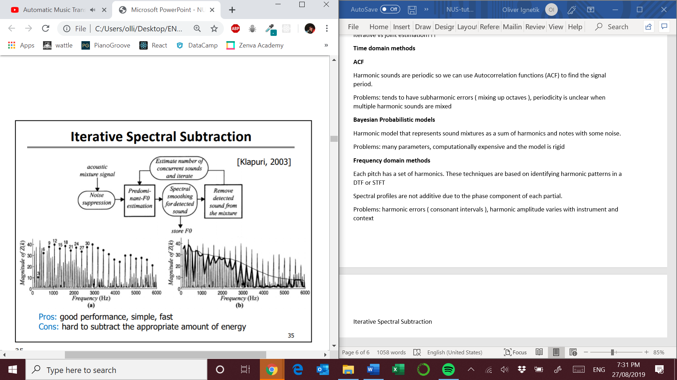

Source: E. Benetos, ‘Automatic Music Transcription’, Tutorial at the Department of Computer Science, National University of Singapore, available: <http://c4dm.eecs.qmul.ac.uk/nus-amt-tutorial/> [Accessed 19/8/2019]

Problems: hard to subtract the appropriate amount of energy

Spectral Peak Modeling

Peak picking based on choosing pitch candidates and their salience.

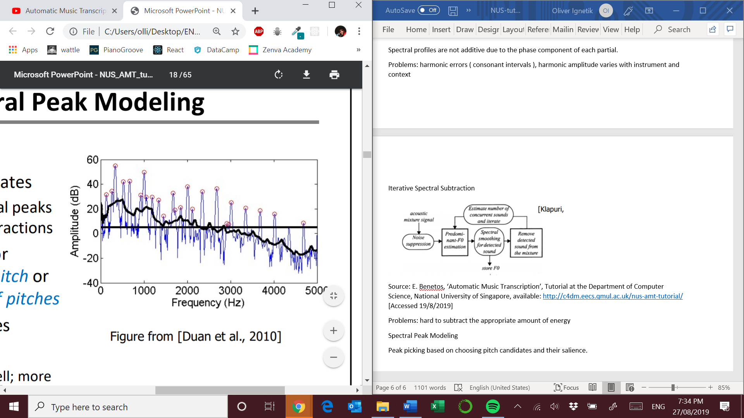

Source: E. Benetos, ‘Automatic Music Transcription’, Tutorial at the Department of Computer Science, National University of Singapore, available: <http://c4dm.eecs.qmul.ac.uk/nus-amt-tutorial/> [Accessed 19/8/2019]

Problems: difficulties dealing with sources that have different loudness

Spectral Peak Modeling – Maximum Likelihood

Probabilistic based peak modeling system based conditional probabilities of observing a peak in the spectrum.

Problems: soft notes are masked more by other notes

Full Spectrum Modelling – Probabilistic

View each note as a tied-Gaussian Mixture Model ( GMM ) . Thus, a signal is a mixture of GMMs

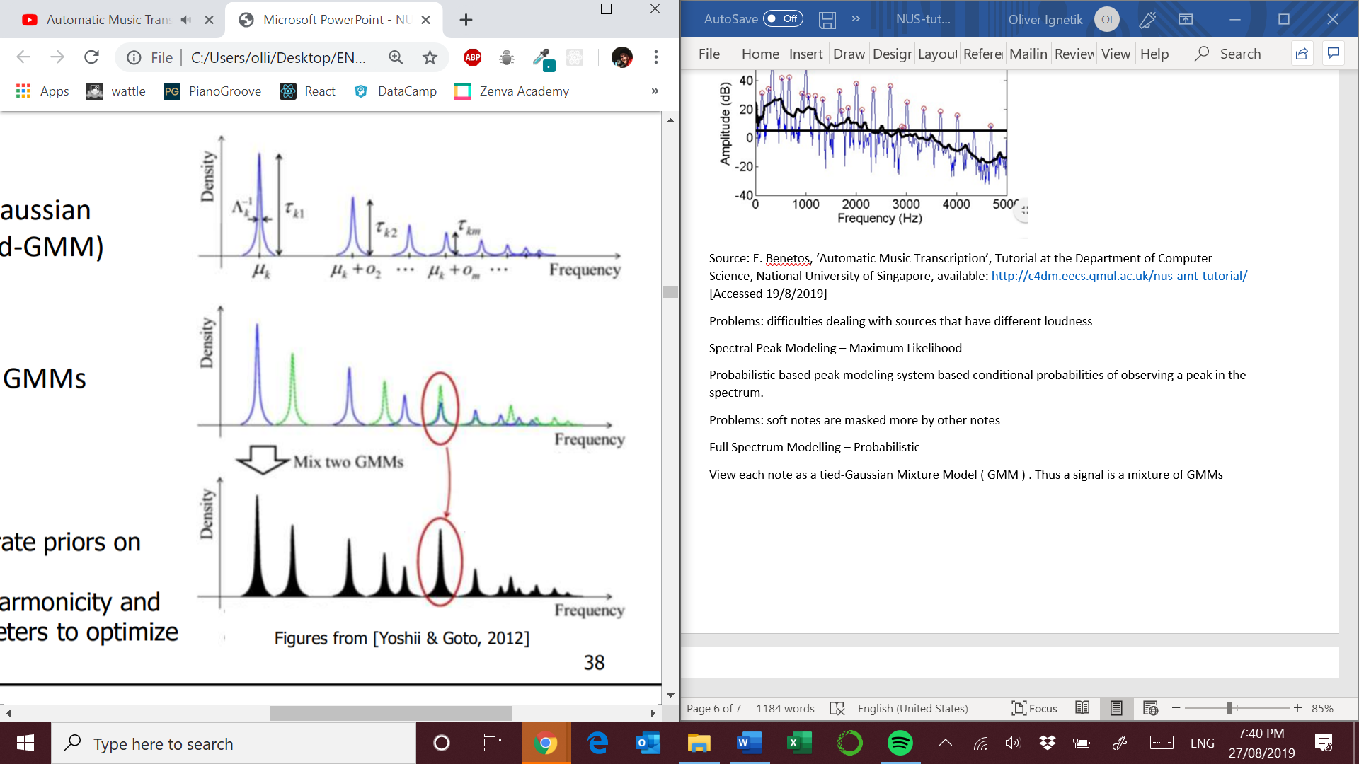

Source: E. Benetos, ‘Automatic Music Transcription’, Tutorial at the Department of Computer Science, National University of Singapore, available: <http://c4dm.eecs.qmul.ac.uk/nus-amt-tutorial/> [Accessed 19/8/2019]

Problems: doesn’t model inharmonicity and assumes that the signals are purely harmonic

Strengths: Computationally efficient, flexible to incorporate priors on parameters

**Spectrogram Decomposition**

* NMF ( Nonnegative Matrix Factorization )
* PCLA ( Probabilistic Latent Component Analysis )

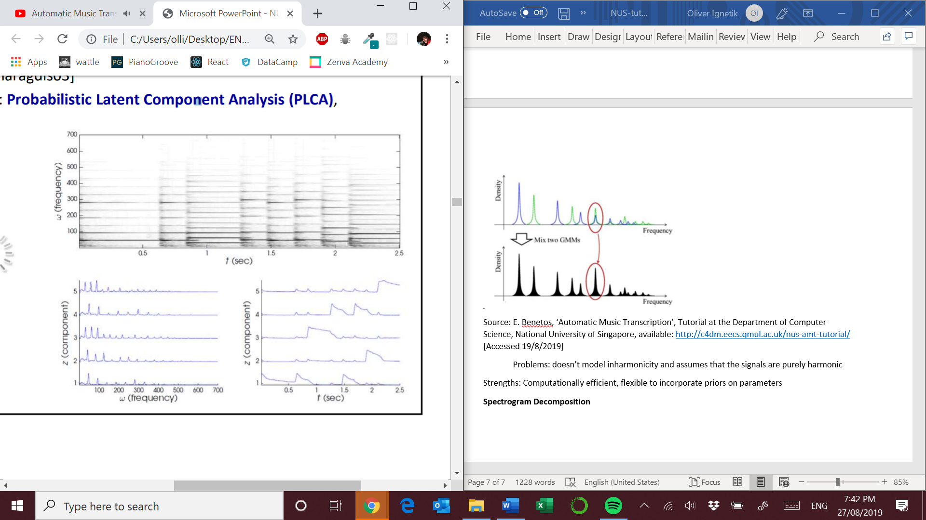

Source: E. Benetos, ‘Automatic Music Transcription’, Tutorial at the Department of Computer Science, National University of Singapore, available: <http://c4dm.eecs.qmul.ac.uk/nus-amt-tutorial/> [Accessed 19/8/2019]

Matrix on the left is the dictionary. Matrix on the right is the activation matrix.

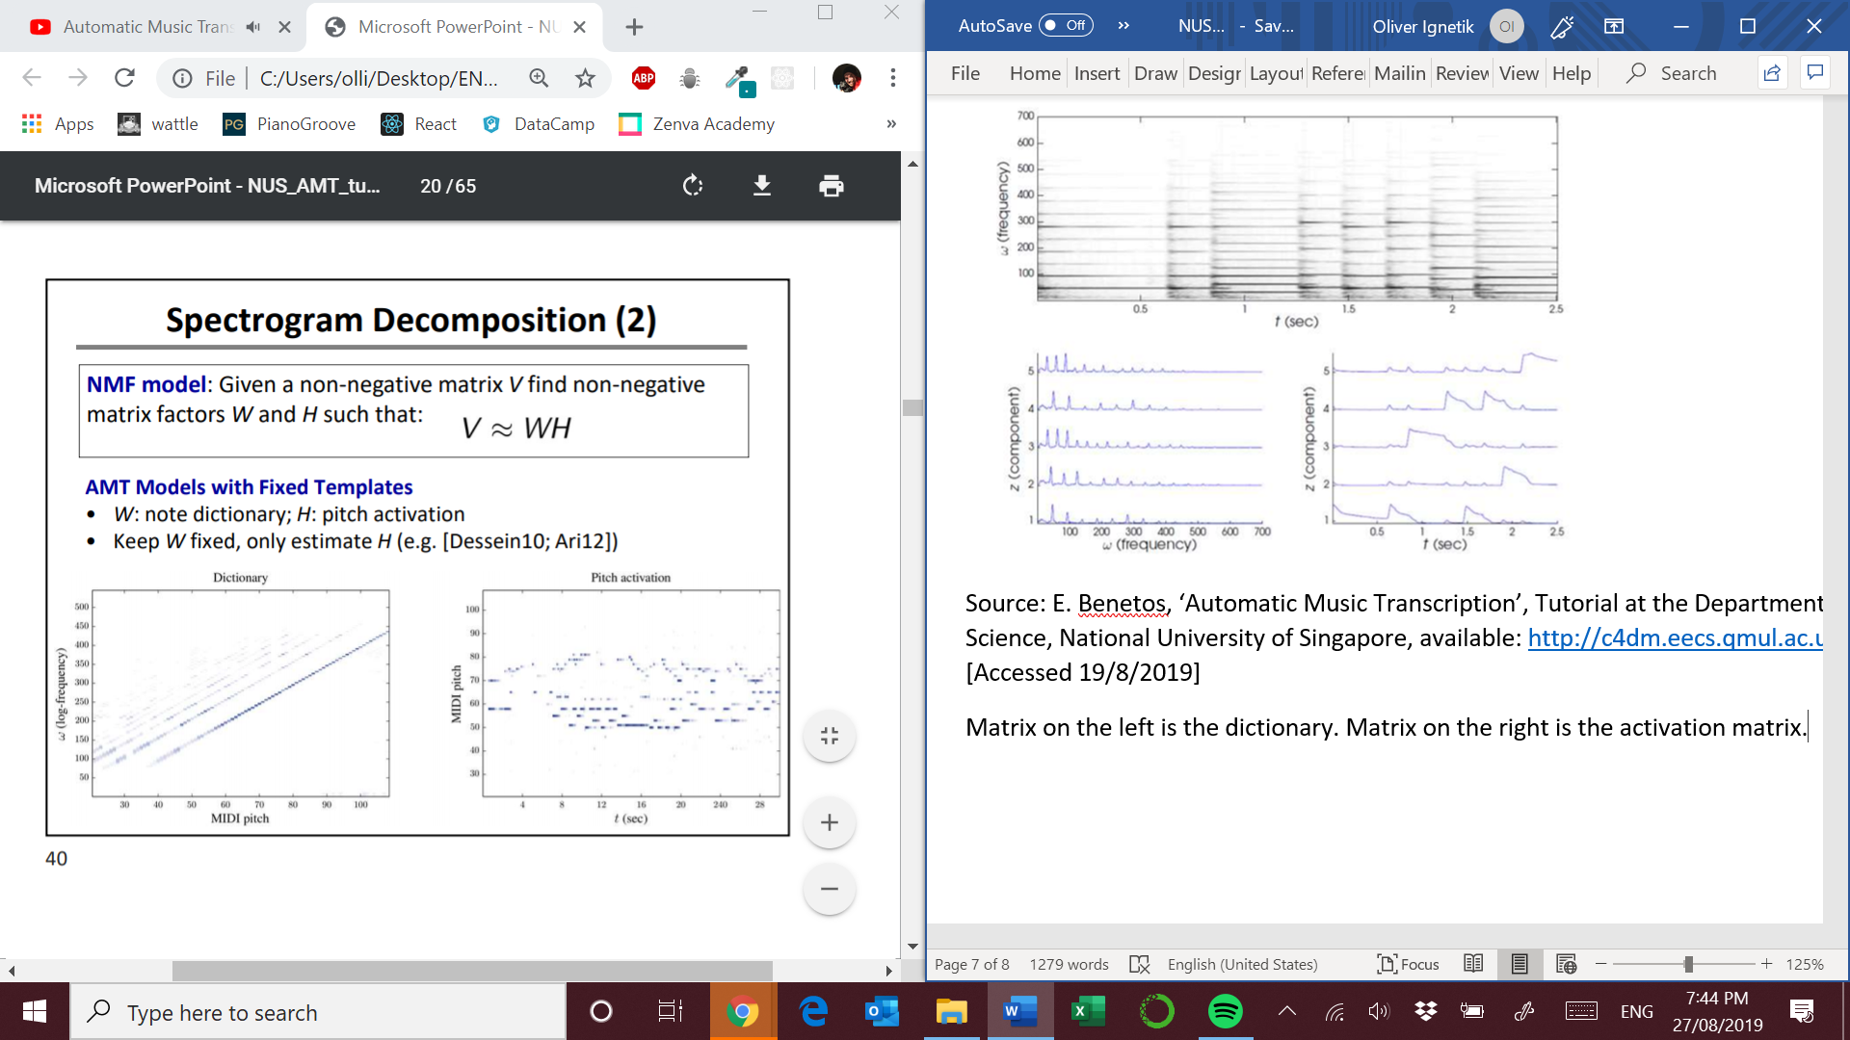

**Fixed templates**

Problems : models perform poorly if the test data does not match the dictionary. ie. Use a different microphone or slightly different tuning.

Strengths: dictionary incorporates prior knowledge on instrument model + acoustics

**Adaptive templates**

Problems: strong assumptions on spectral profiles and relies on good initial estimates

Strengths: dictionary closely matches test data

**PCLA**

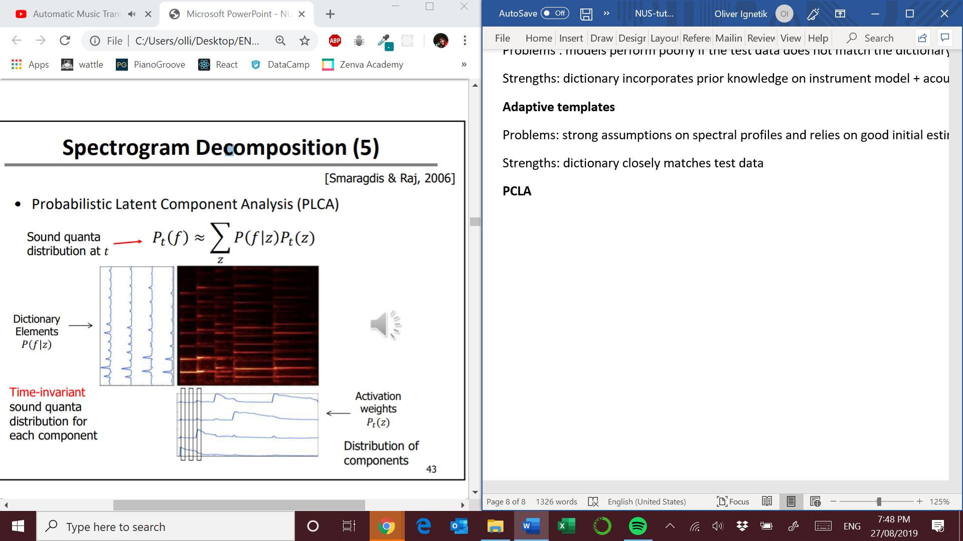

Source: E. Benetos, ‘Automatic Music Transcription’, Tutorial at the Department of Computer Science, National University of Singapore, available: <http://c4dm.eecs.qmul.ac.uk/nus-amt-tutorial/> [Accessed 19/8/2019]

This allows us to plug in probabilistic models that are powerful.

**Convolutive models**

V = W * H

Extract shifted structures in spectrograms by using log-frequency scales. The intervals in a equal tempered scales are spaced equally logarithmically. NNs use a similar approach of convolving patterns along a larger sampling area.

* SIPCLA : fixed templates
* SIPCLA : adaptive templates

Problems: on improvement over linear models in some cases of instruments

Strengths: can model key changes and model tuning changes

**Classification-based Methods**

View transcription as a multi-label classification. Each midi number is a class

Strengths: simple idea, no acoustical prior knowledge

Problems: only outputs quantized pitches, requires lots of training data ( there are so many class combinations ! ) , overfits data and hard to adapt to different instruments

Some classification methods are SVMs, NNs, RNNs and CNNs

**NNs**

They are based on a collection of connected units or nodes. They can learn a nonlinear function form input to output via an optimization algorithm like a stochastic gradient descent. Hidden layers are similar to hidden variables in HMMs.

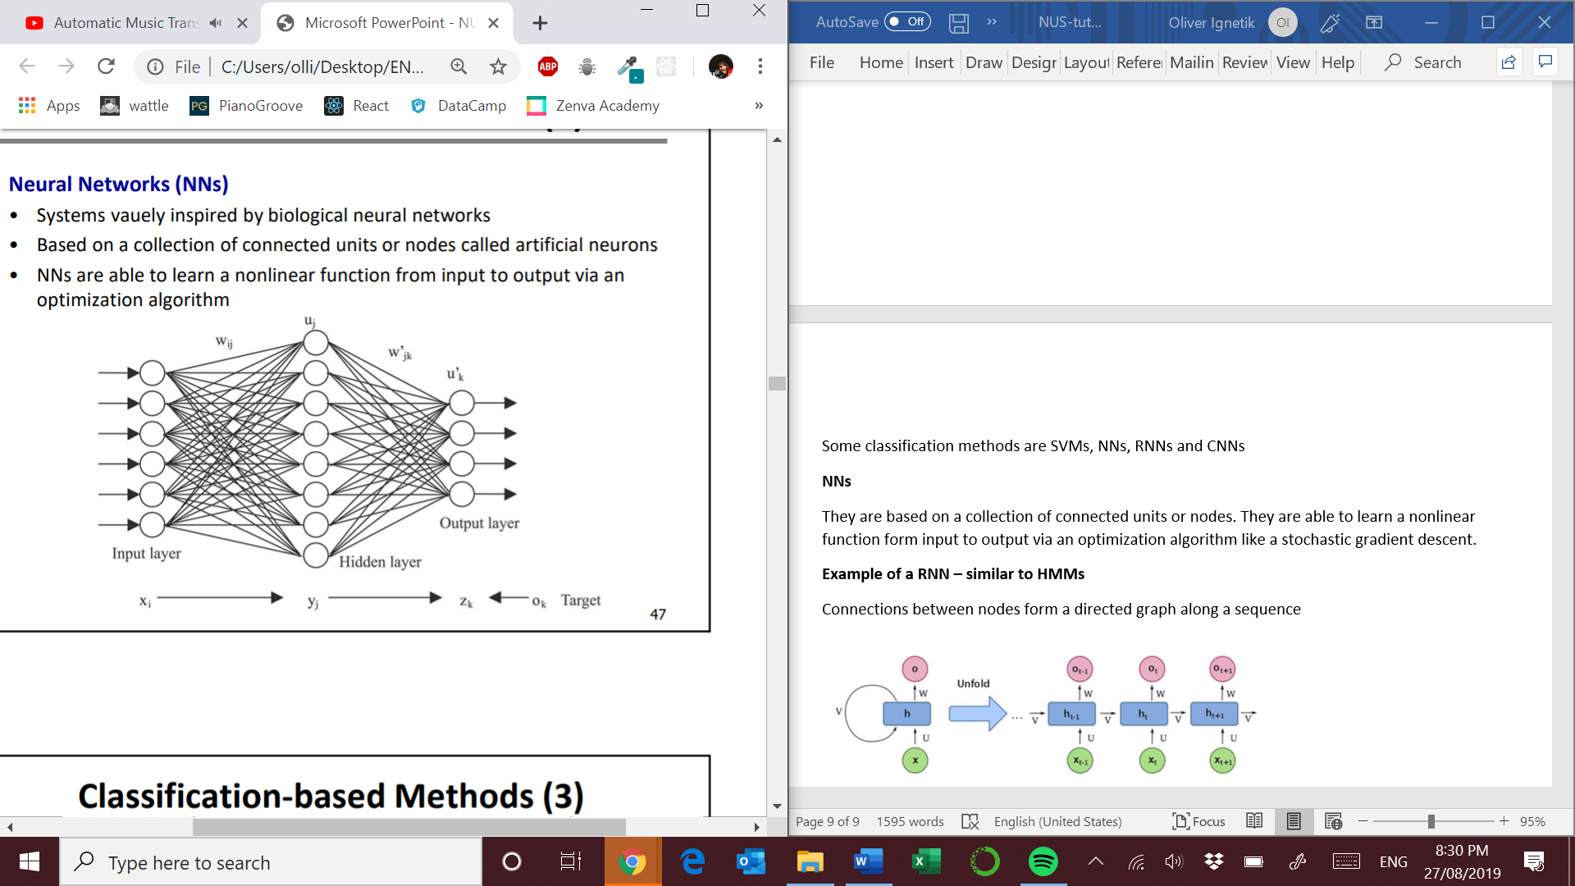

Source: E. Benetos, ‘Automatic Music Transcription’, Tutorial at the Department of Computer Science, National University of Singapore, available: <http://c4dm.eecs.qmul.ac.uk/nus-amt-tutorial/> [Accessed 19/8/2019]

**Example of a RNN – similar to HMMs**

Connections between nodes form a directed graph along a sequence

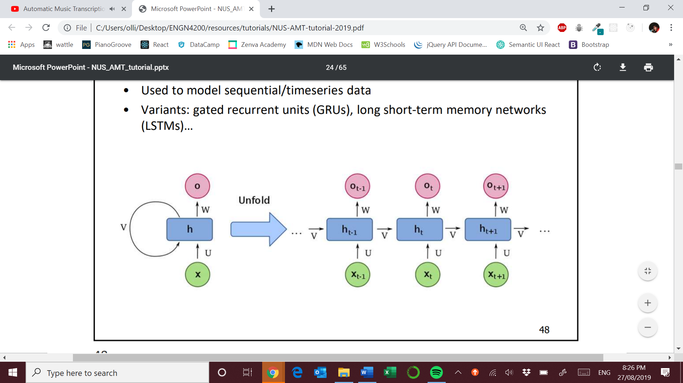

Source: E. Benetos, ‘Automatic Music Transcription’, Tutorial at the Department of Computer Science, National University of Singapore, available: <http://c4dm.eecs.qmul.ac.uk/nus-amt-tutorial/> [Accessed 19/8/2019]

Some variants:

* Gated recurrent units (GRU)
* Long short-term memory (LTSM)

**Example of CNN – Shift invariant neural networks**

* Convolutional layers apply a convolution operation on the input passing the result to the next layer.
* Convolve the filter ( small repetitive pattern ) over the structure input
* It is commonly used in image processing.

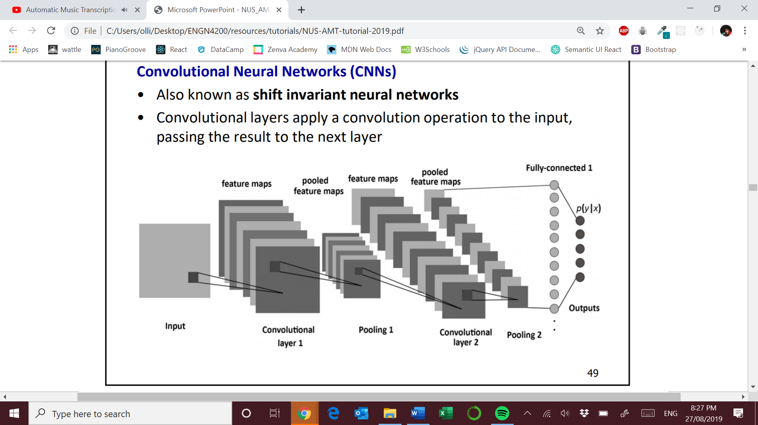

Source: E. Benetos, ‘Automatic Music Transcription’, Tutorial at the Department of Computer Science, National University of Singapore, available: <http://c4dm.eecs.qmul.ac.uk/nus-amt-tutorial/> [Accessed 19/8/2019]

**Some papers on state-of-the-art NNs**

* Bock and Schedl, 2012 : <https://ieeexplore.ieee.org/document/6287832>
* Sigtia et al, 2016: <https://arxiv.org/pdf/1508.01774>

Check out Bibliography file on tutorial website

**Note level ( note tracking )**

Essentially identify start and end points of the note

* Onset detection followed by multi pitch estimation between onset
* Post processing of frame-level pitch estimates
* Or directly from audio

Use of HMMs to model sound states of notes. This can smooth the spectrogram.

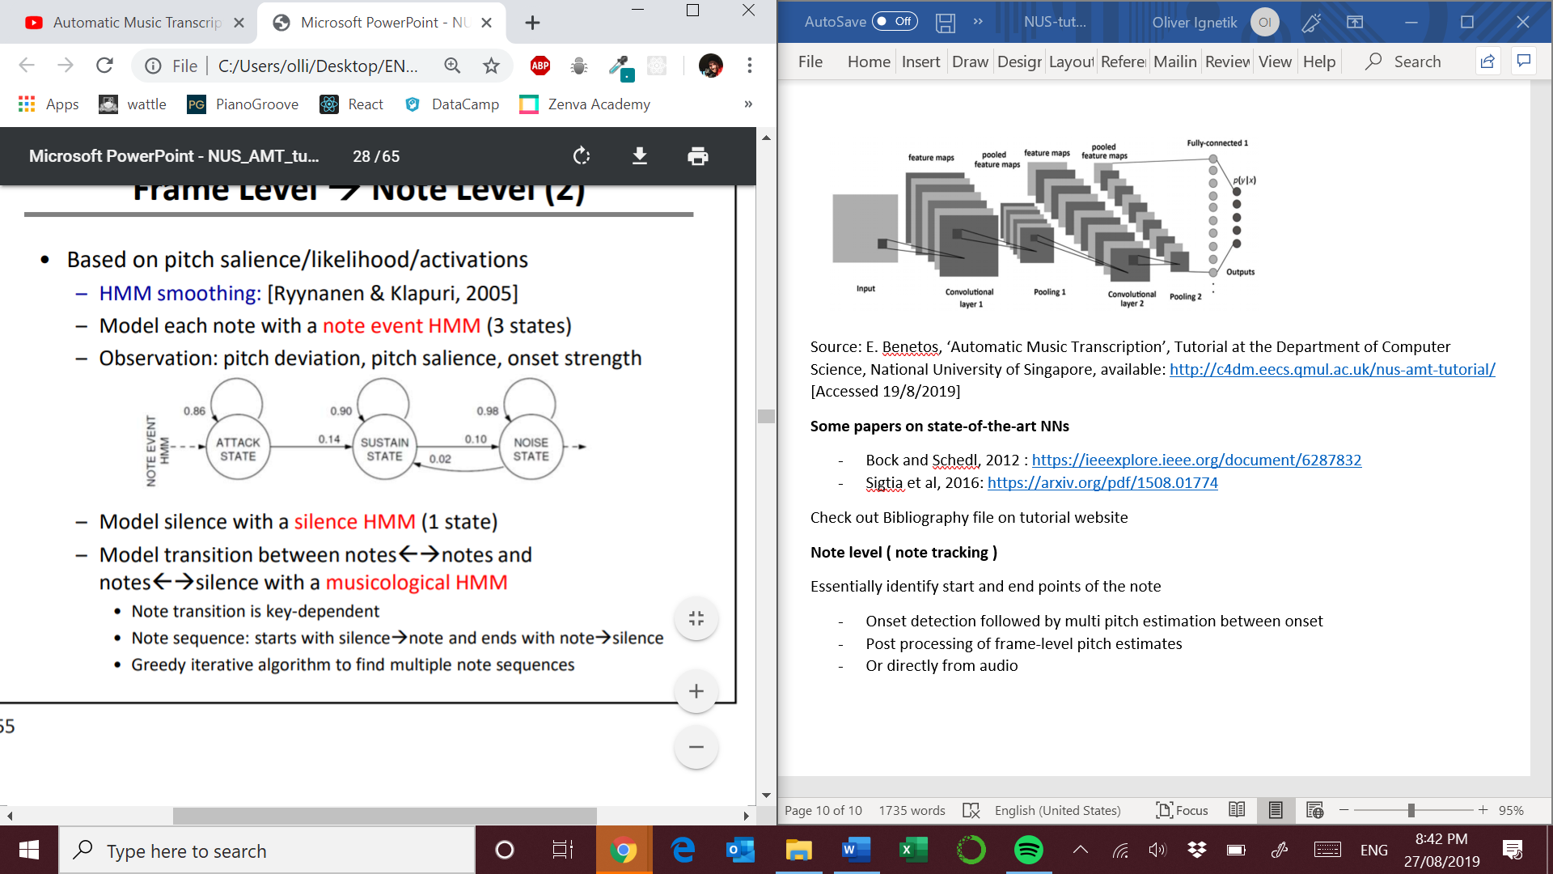

Source: E. Benetos, ‘Automatic Music Transcription’, Tutorial at the Department of Computer Science, National University of Singapore, available: <http://c4dm.eecs.qmul.ac.uk/nus-amt-tutorial/> [Accessed 19/8/2019]

This method only works for tracking the melody ( ie. one voice ) because HMM variables are discrete. But:

* Note transitions are key-dependent
* Note sequences use a musicological HMM

The current state of the art method for end-to-end note tracking is Google response to piano transcription. See reference [Hawthorne et al, 2018]

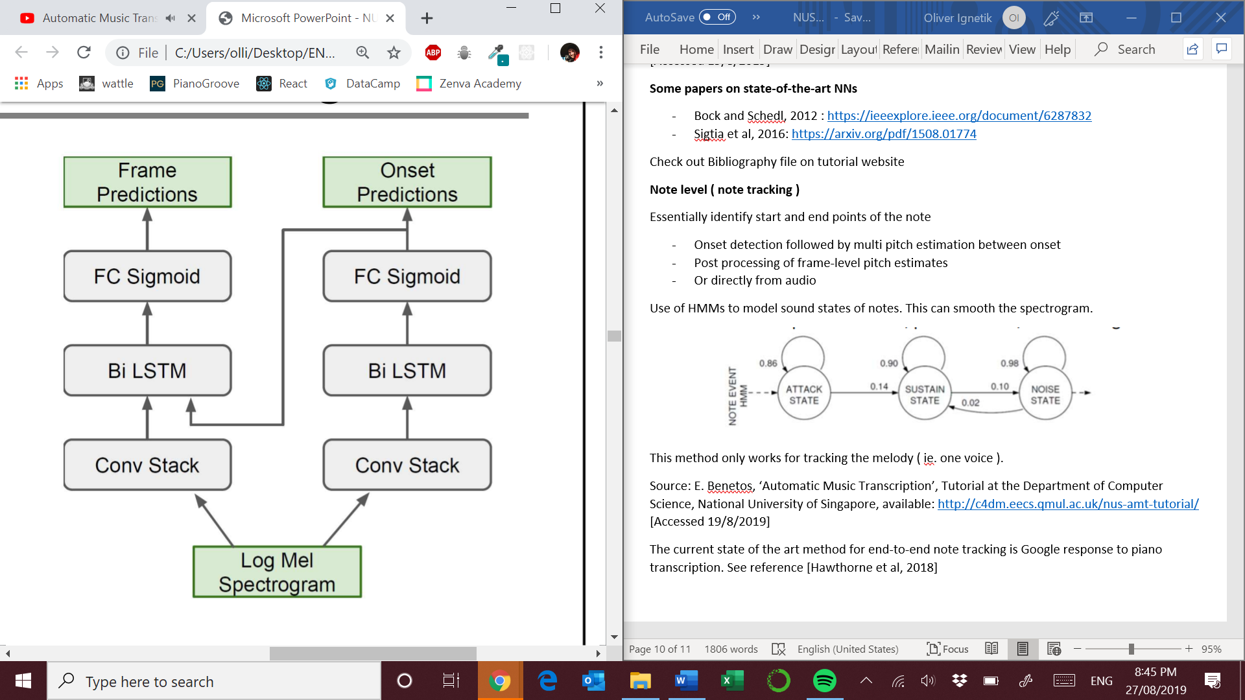

Source: E. Benetos, ‘Automatic Music Transcription’, Tutorial at the Department of Computer Science, National University of Singapore, available: <http://c4dm.eecs.qmul.ac.uk/nus-amt-tutorial/> [Accessed 19/8/2019]

This is an extremely well performing model for piano recordings. **But other instruments have not be tested with this model !**

**Timbre tracking**

Assign each note to a specific instrument source.

Supervised

* Train timbre models
* Apply timbre models during pitch estimation
* Adapt training timbre models to sources in mixture

Unsupervised

* Cluster pitch estimates according to timbre

**Timbre Tracking – Duan et al., 2014**

Constrained clustering

* Objective: maximize timbre consistency within clusters
* Constraints based on pitch locations: must links and cannot-links

Timbre representation

* Harmonic structure feature

Iterative algorithm

* Update clustering to decrease objective function and satisfy more constraints

**Timbre Tracking – Mysore and Smaragdis, 2009**

Shift invariant PLCA on CQT

Assumption: instrument spectrum shape invariant to pitch

Constraints: Note activation over frequency shift is unimodal, note activation over time is smooth

It is essentially a pitch clustering algorithm

Problems : does not recognize absolute pitch

Strengths : pitch estimation and timbre tracking are performed at the same time

**Datasets**

**SLIDE 63 / PAGE 31 of NUS tutorial slides**

**Types of annotations**

**Ground truths are piano roll representations of performances !**

Annotations can be generated by:

* Automatically from a Disklavier piano or by single pitch detection from multi-track recordings
* Semi-automatically ( manual corrections from F0 tracking or alignment )
* Manually (annotating the music )

**Dataset types**

1. Chords/isolated notes
2. Music pieces

**Performance pieces / synthesized scores**

Training models based solely on synthesized music means your transcription system will not work well in real life situations. They do not take into account the impulse response of the room, or the spectral characteristics of the instruments etc.

**POLPYHONIC DATASETS**

**SLIDE 66/ PAGE 33**

**EVALUATIONS METRICS**

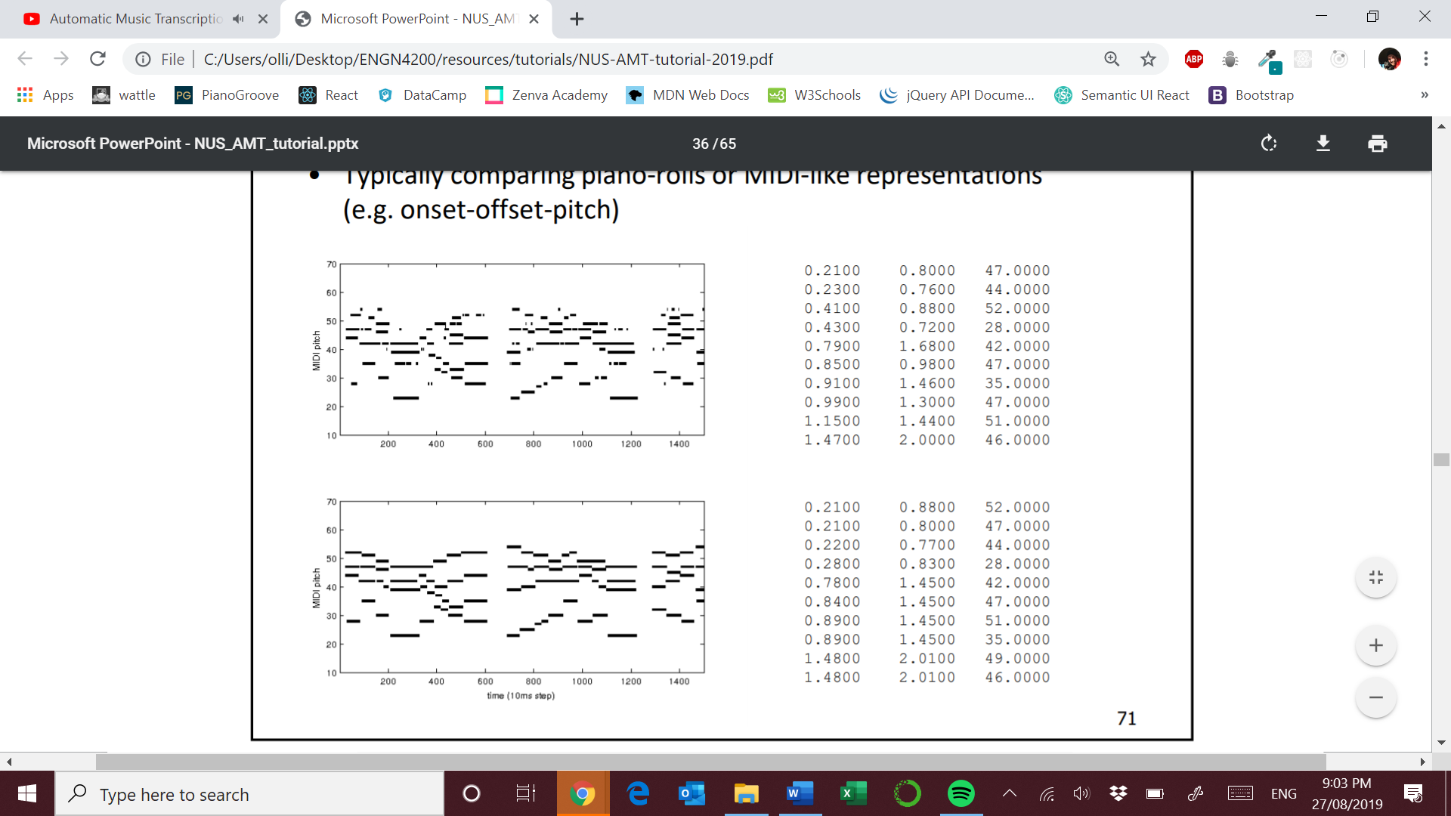

Source: E. Benetos, ‘Automatic Music Transcription’, Tutorial at the Department of Computer Science, National University of Singapore, available: <http://c4dm.eecs.qmul.ac.uk/nus-amt-tutorial/> [Accessed 19/8/2019]

**Expected output**

MIDI output = [ onset_time, offset_time, pitch ]

**Tolerances**

Note onset : -/+ 50ms

Onset/offset : -/+ 50ms

Pitch : -/+ quarter tone

Instrument assignment: pitch also have to be assigned to the correct source

**Relations to other problems**

* Source Separation – concepts and algorithms from source separation can be used in AMT
* Score following
* Score informed transcription – Score informed piano tutoring based on NMF
* Content based retrieval – music tagging etc.
* Systematic/computational musicology – repeated themes and patterns in recordings, estimation of instrument tunings and inharmonicity

**Further extensions and advanced topics**

* Percussive instruments – used to reduce percussive sounds in recordings. Higher temporal accuracy is needed in this case, **open problem**
* Singing voice - MIDI representations are inadequate for representing signing, many challenges associated with intonation and phonation modes and drift of pitches . <https://code.soundsoftware.ac.uk/projects/tony>. **Instrument and singing voice together are still unsolved**
* Non-western music- most study is based on 12-TET and essential major/minor modes, systems fall apart when subjected to data that is microtonal
* Music language models – errors in most systems are not musically meaningful, HMM chord models and note models. **Check Sigtia et al, 2016 for Hybrid acoustic-language model which combines NN acoustic model with a RNN-NADE for language modeling** <https://arxiv.org/pdf/1508.01774.pdf> , <https://www.eecs.qmul.ac.uk/~simond/pub/2015/Sigtia-et-al-ICASSP2015.pdf>
* Complete AMT – sequence-to-sequence model for monophonic transcription with output in lilypond notation ??
* Evaluation metrics – musically meaningful errors ( key errors, semitones eg. ), subjective tests for listening and examining teachers grading procedures for dictation.

# References

Check the tutorial website